Installing Express Edition

Step 1:

* <https://www.microsoft.com/en-gb/sql-server/sql-server-downloads>
* Click on the **Download** button for the **Express** version free edition. This will initiate the download of the installer
* Double click the installer to start it
* In the **Installation Type** screen, choose **Custom**
* Click **Install** on the next screen
* Once you get to the SQL Server Installation Center screen, click on the **New SQL Server stand-alone installation** link
* This will open another window which will start the final installation of SQL Server
* For every screen, click **Next** for the default options
* In the **Database Engine Configuration** screen, in the **Server Configuration** tab, choose **Authentication Mode** as **Mixed**. Enter an administrator password and click on **Next**
* After the installation completes, the Installation window will close
* In the previous window, click on **Install SQL Server Management Tools**. This will open a download page in the browser
* In the page click on the link **Download SQL Server Management Studio 18.2**
* Save the file which is downloaded
* Double click the installer file and click on **Install** in the opening screen
* After installation of the Management Studio completes, the computer will restart.

**Step 2:** Testing Installation

* Once the computer has restarted, click on **Start** and run **SQL Server Management Studio**

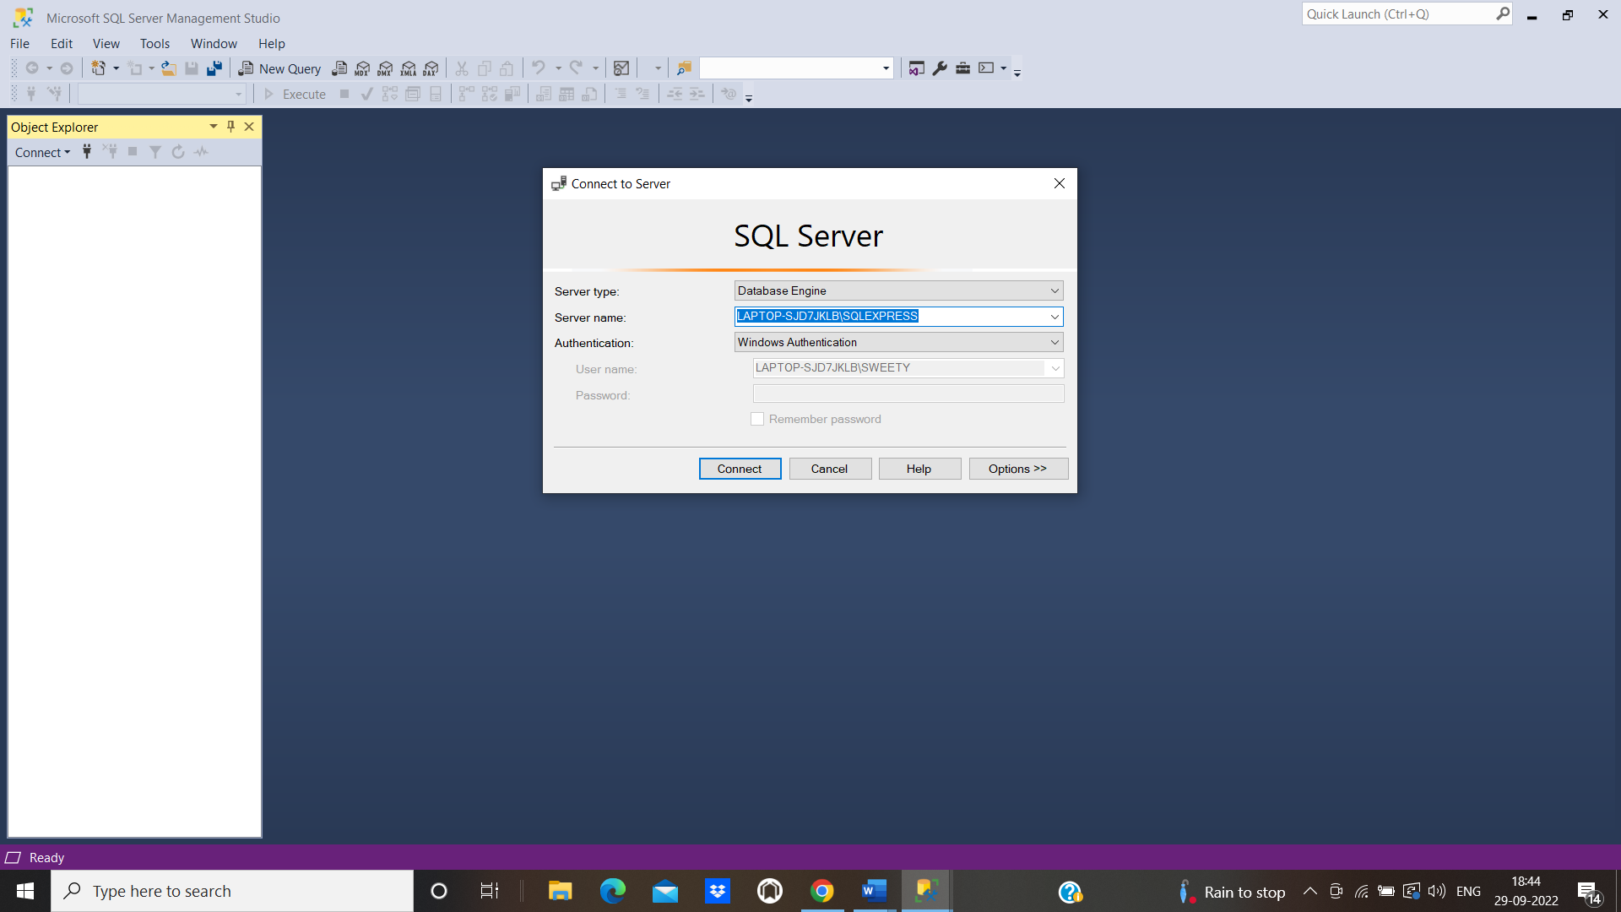

* In the login screen, choose **Authentication** as SQL Server authentication. Put **Login** credentials set during installation.
* It will show the **Object Explorer** window

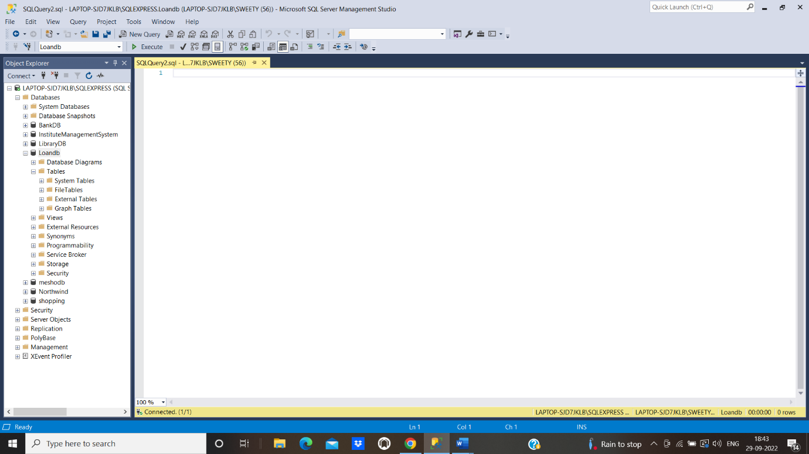

* Close and exit the Management Studio and write queries and pushing the code to git repo